Spring 2023: CS5720

Neural Networks & Deep Learning - ICP-1

1. Write a python program for the following:

1. Input the string “Python” as a list of characters from the console, delete at least 2 characters, reverse the resultant string and print it.

* Sample input :

python

* Sample output:

ntyp

Ans

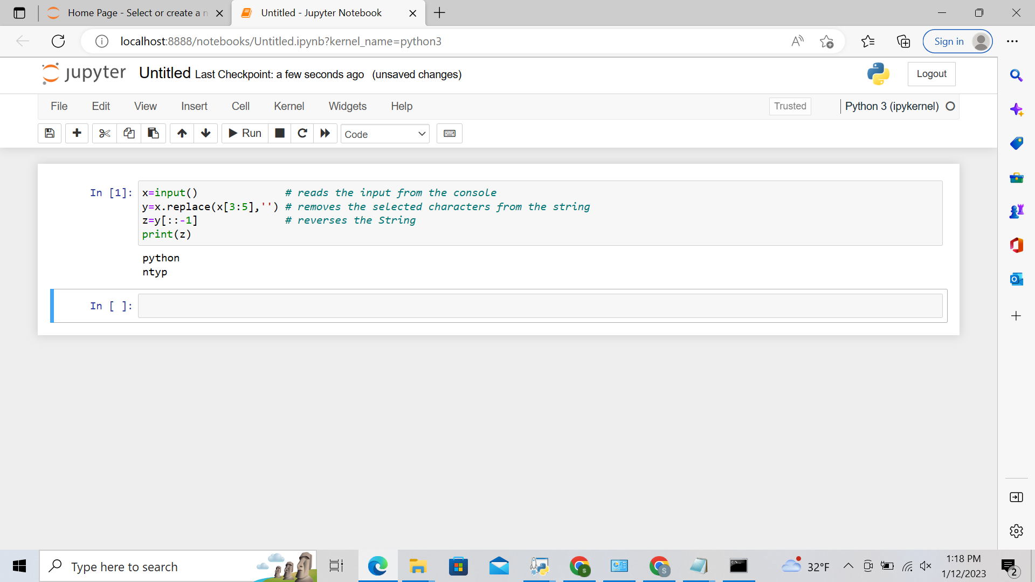

b) Take two numbers from the user and perform at least 4 arithmetic operations on them.

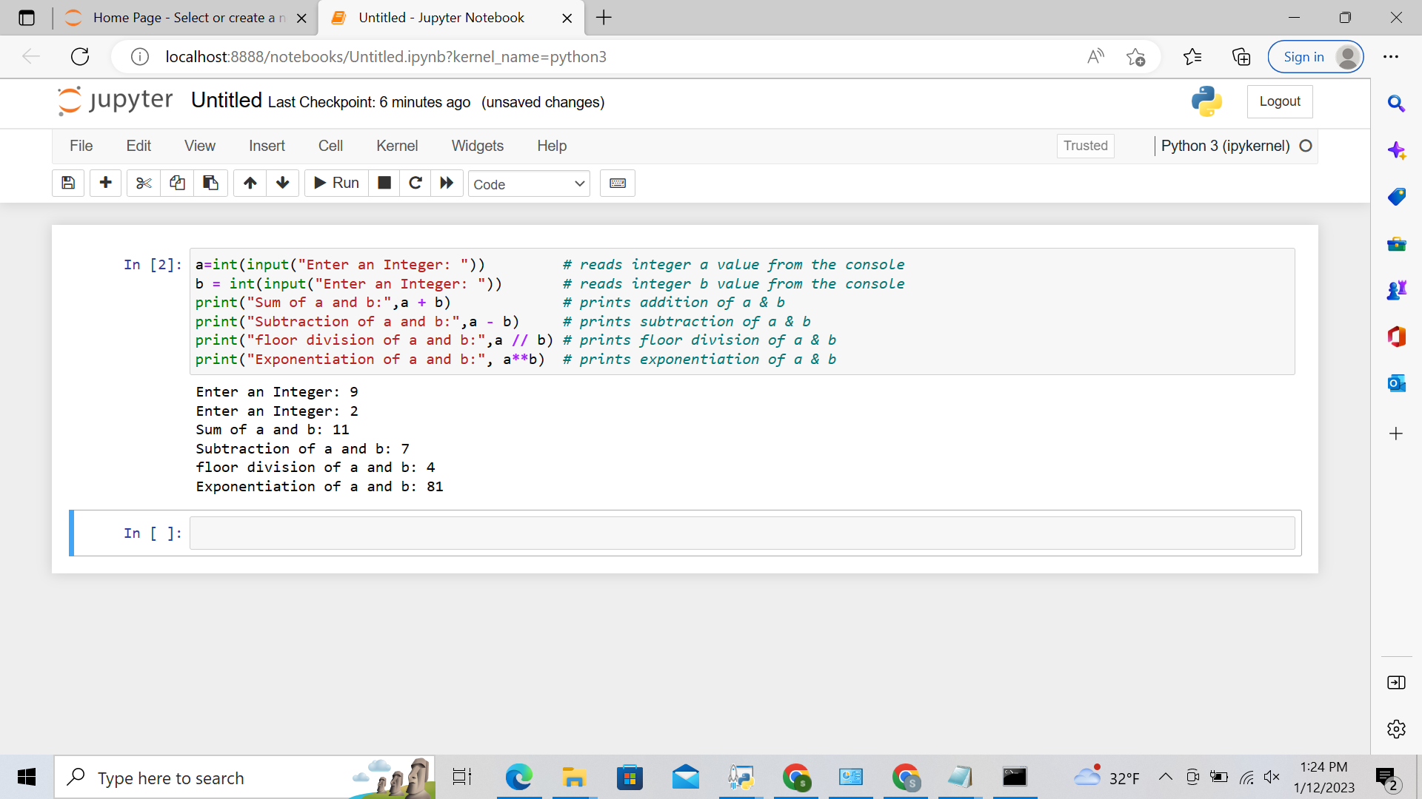

2. Write a program that accepts a sentence and replace each occurrence of ‘python’ with ‘pythons’.

* Sample input:

I love playing with python

* Sample output:

I love playing with pythons

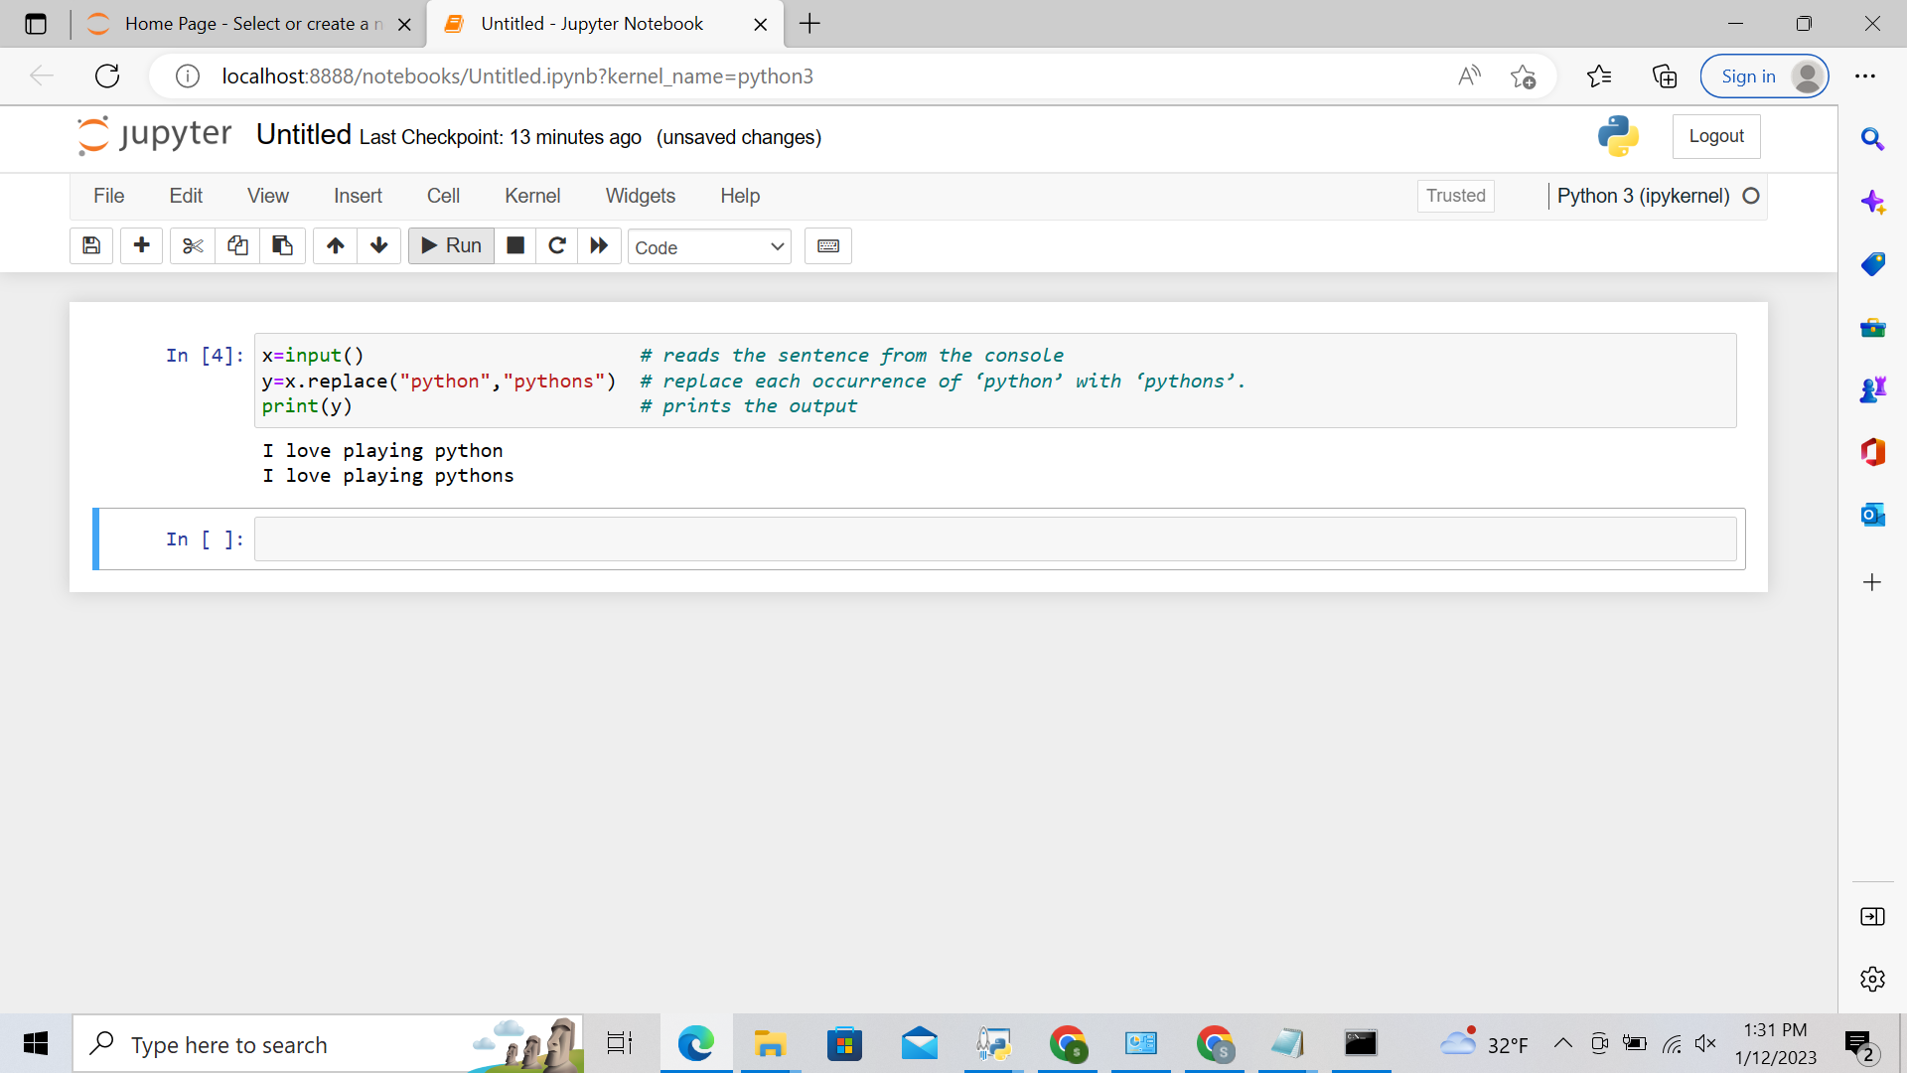

3. Use the if statement conditions to write a program to print the letter grade based on an input class score. Use the grading scheme we are using in this class.

